
FRONT END DEVELOPMENT FRAMEWORKS AND
UI ENGINEERING
25CS1201E

Co-ordinator : Dr. Y. Subbarayudu
ASSIGNMENT
Name: P. Siddhu Bhagavan
Roll No: 2520040095
Section:14
CONTENT

Title Pg
- Assignment-1 3
- Assignment-2 7
- Assignment-3 10
- Assignment-4 13
- Assignment-5 15
- Assignment-6 19
- Assignment-7 23
- Assignment-8 28
- Assignment-9 31
- Assignment-10 34
- Git Hub Repository Link 36

ASSIGNMENT-1
Develop static pages (using Only HTML) of an online Book store. The pages should consist home page, registration, user-login, books, catalogue
i) Aim
To develop static web pages using only HTML for an online book store, including Home, Registration, User Login and Books Catalogue pages that are linked with simple navigation.
ii) Description
- In this assignment, an online book store interface is designed using basic HTML tags without any CSS or JavaScript.
- The Home page contains the title of the website, a short description and navigation links to the other pages.
- The Registration page and Login page use HTML form controls such as text fields, password fields and text areas to collect user details.
- The Books Catalogue page displays a list of books in tabular form with columns such as Title, Author, Category and Price.
- All the pages are connected using HTML anchor tags so that the user can move between Home, Login, Registration and Catalogue pages easily in a web browser.
iii) Program
File: index.html (Home Page)
<!DOCTYPE html> <html> <head> <title>Online Book Store - Home</title> </head>
<body> <h1>Welcome to Online Book Store</h1>
<p>Find and buy your favourite books.</p>
<nav> <a href="index.html">Home</a> | <a href="login.html">Login</a> | <a href="register.html">Register</a> | <a href="catalog.html">Books Catalog</a> </nav>
<h2>Featured Categories</h2>
<ul> <li>Programming</li> <li>Fiction</li> <li>Science</li> <li>Business</li> </ul>
</body> </html>

File: register.html (Registration Page)
<!DOCTYPE html> <html> <head> <title>Online Book Store - Registration</title> </head>
<body> <h1>User Registration</h1>
<nav> <a href="index.html">Home</a> | <a href="login.html">Login</a> | <a href="register.html">Register</a> | <a href="catalog.html">Books Catalog</a> </nav>
<form> <label>Full Name:</label> <input type="text" name="fullname"><br><br> <label>Email:</label> <input type="email" name="email"><br><br>
<label>Username:</label> <input type="text" name="username"><br><br> <label>Password:</label> <input type="password" name="password"><br><br> <label>Address:</label> <textarea name="address" rows="3" cols="30"></textarea><br><br> <input type="submit" value="Register"> <input type="reset" value="Clear"> </form>
</body> </html>

File: login.html (User Login Page)
<!DOCTYPE html> <html> <head> <title>Online Book Store - Login</title> </head>
<body> <h1>User Login</h1>
<nav> <a href="index.html">Home</a> | <a href="login.html">Login</a> | <a href="register.html">Register</a> | <a href="catalog.html">Books Catalog</a> </nav>
<form> <label>Username:</label> <input type="text" name="username"><br><br> <label>Password:</label> <input type="password" name="password"><br><br> <input type="submit" value="Login"> <input type="reset" value="Reset"> </form>
</body> </html>

File: catalog.html (Books Catalog Page)
<!DOCTYPE html> <html> <head> <title>Online Book Store - Catalog</title> </head>
<body> <h1>Books Catalog</h1>
<nav> <a href="index.html">Home</a> | <a href="login.html">Login</a> | <a href="register.html">Register</a> | <a href="catalog.html">Books Catalog</a> </nav>
<table border="1" cellpadding="8">
<tr> <th>Title</th> <th>Author</th> <th>Category</th> <th>Price (₹)</th> </tr> <tr> <td>Learning JavaScript</td> <td>John Doe</td> <td>Programming</td> <td>499</td> </tr> <tr> <td>React Basics</td> <td>Jane Smith</td> <td>Programming</td> <td>599</td> </tr> <tr> <td>Data Structures</td> <td>ABC Author</td> <td>Computer Science</td> <td>450</td> </tr> </table>
</body> </html>

iv) Input and Output
- Input:
The user opens the HTML files in a web browser and may enter data into the Registration and Login forms, such as full name, email, username and password.
- Output:
The browser displays the Home page, Registration form, Login form and Books Catalogue page as static web pages. The user can navigate between the pages using the links in the navigation menu and view the list of books shown in the catalogue table.
v) Result
The static web pages for the online book store were successfully created using only HTML and executed in a web browser. The Home, Registration, Login and Books Catalogue pages are properly linked and display the required content, fulfilling the objective of the assignment.
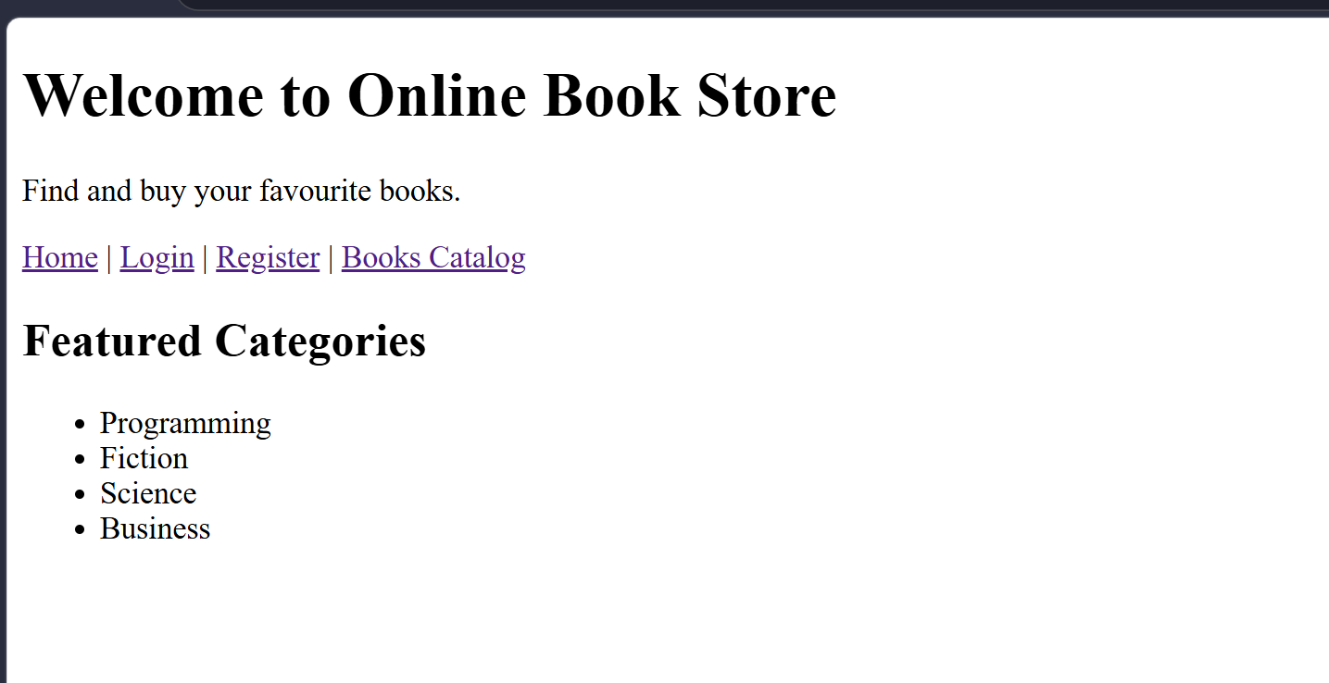
Home Page

Login Page
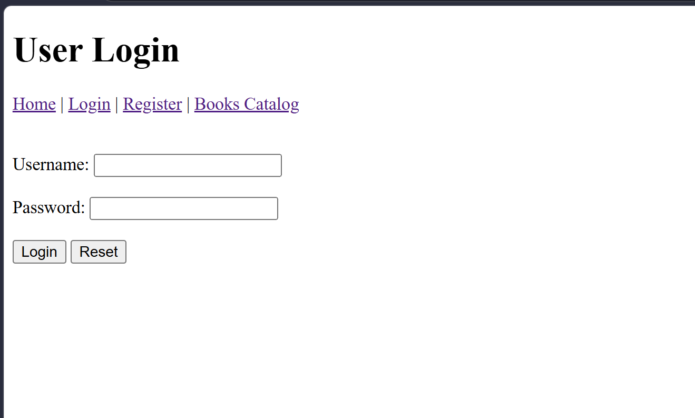

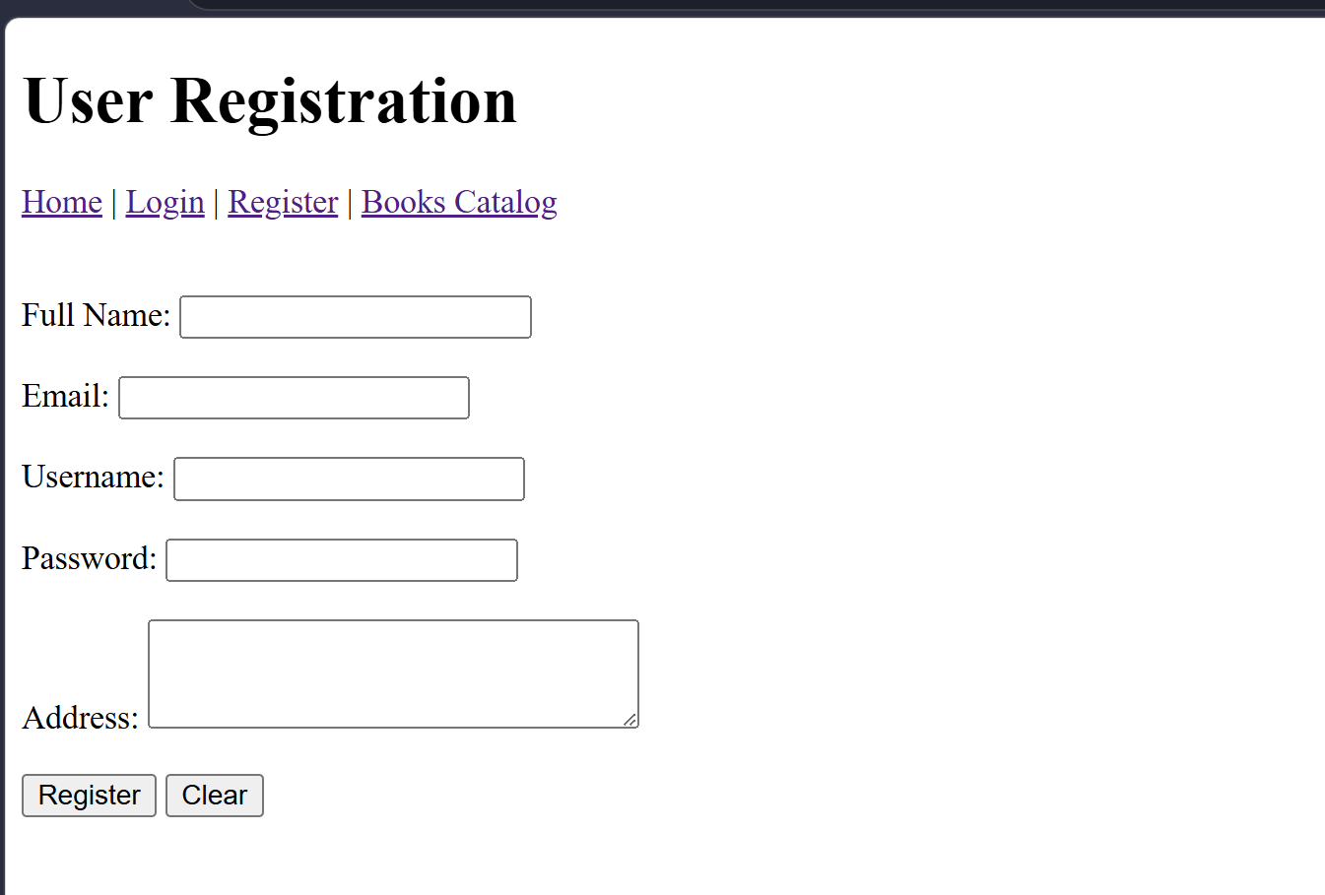
Register Page

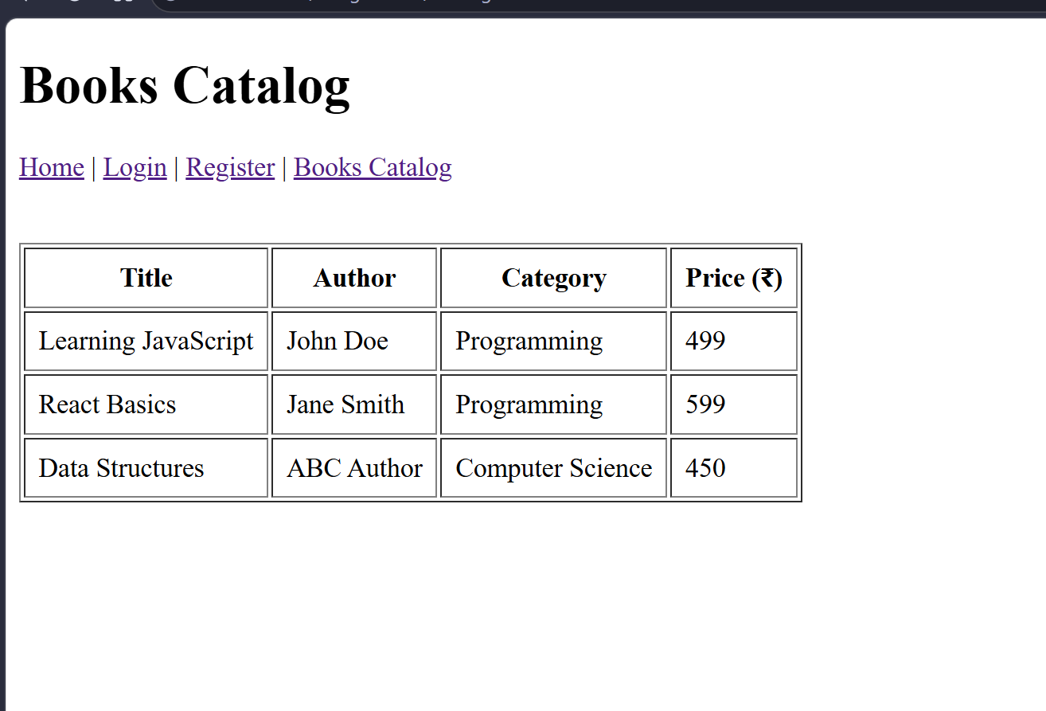
Catalogue Page

ASSIGNMENT-2
Write HML and CSS which will display the book information in table format . Which includes the following?
Title of Book, Author Name, ISBN Number, Publisher , Edition, Price
i) Aim
To design a web page using HTML and CSS that displays book information in a neatly formatted table containing the Title of Book, Author Name, ISBN Number, Publisher, Edition and Price.
ii) Description
- In this assignment, an HTML table is used to display multiple books with columns for title, author, ISBN number, publisher, edition and price.
- Basic CSS is applied to style the table by adding borders, padding, alternating row colors and a heading style to make the data easy to read.
- The table is placed at the center of the page with a simple page heading and background color to improve the overall appearance of the book information.
iii) Program
File: booktable.html
<!DOCTYPE html> <html> <head> <title>Book Information Table</title>
<style> body { font-family: Arial, sans-serif; background-color: #f2f2f2; }
h1 { text-align: center; color: #333333; }
.container { width: 80%; margin: 20px auto; }
table { width: 100%; border-collapse: collapse; background-color: #ffffff; }
th, td { border: 1px solid #555555; padding: 10px; text-align: center; }
th { background-color: #4CAF50; color: white; }
tr:nth-child(even) { background-color: #f9f9f9; }
tr:nth-child(odd) { background-color: #e9f5e9; }
</style> </head>
<body>
<div class="container">
<h1>Book Information</h1>
<table> <tr> <th>Title of Book</th> <th>Author Name</th> <th>ISBN Number</th> <th>Publisher</th> <th>Edition</th> <th>Price (₹)</th> </tr>
<tr> <td>Learning JavaScript</td> <td>John Doe</td> <td>978-1-23456-789-7</td> <td>TechBooks</td> <td>2nd</td> <td>499</td> </tr>
<tr> <td>React Fundamentals</td> <td>Jane Smith</td> <td>978-1-98765-432-1</td> <td>WebPress</td> <td>1st</td> <td>599</td> </tr>
<tr> <td>Data Structures in C++</td> <td>ABC Author</td> <td>978-0-11111-222-3</td> <td>CS Publications</td> <td>3rd</td> <td>650</td> </tr>
<tr> <td>Database Systems</td> <td>XYZ Writer</td> <td>978-9-87654-321-0</td> <td>InfoBooks</td> <td>4th</td> <td>720</td> </tr>
</table>
</div>
</body> </html>
iv) Input and Output
- Input:
The user opens the booktable.html file in a web browser; no user data entry is required because the book information is already stored in the HTML table.
- Output:
The browser displays a styled table showing a list of books with columns for Title of Book, Author Name, ISBN Number, Publisher, Edition and Price, formatted using CSS for better readability.

v) Result
The HTML and CSS program was successfully executed in the web browser and displayed the book information in a well-formatted table with headings and styled rows, fulfilling the assignment requirements.
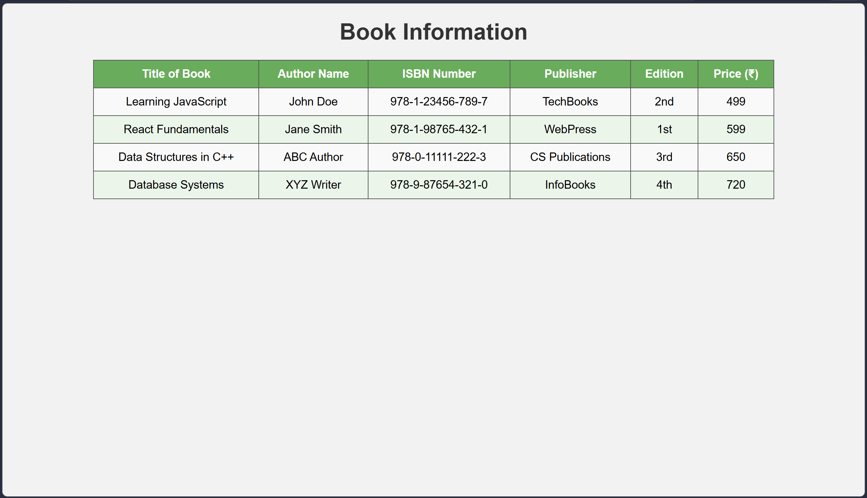

ASSIGNMENT-3
Write an ReactJS which will display the book information. Which includes the following?
Title of Book, Author Name, ISBN Number, Publisher, Edition, Price

i) Aim
To develop a simple ReactJS application that displays book information using a React component, showing the Title of Book, Author Name, ISBN Number, Publisher, Edition and Price in a structured layout
ii) Description
- In this assignment, a basic ReactJS functional component is created to render book details as a list of cards on the web
- An array of JavaScript objects is used to store multiple books, and the map() function is used inside JSX to display each book’s Title, Author, ISBN Number, Publisher, Edition and Price
- The main App component returns simple JSX with a heading and a list of book items so that the program remains easy to understand and implement for beginners.
iii) Program
You can assume a basic Create React App structure with index.js rendering the App component.
Vite structure: src/main.jsx and src/App.jsx
File:main.jsx
import React from "react";
import ReactDOM from "react-dom/client";
import App from "./App";
const root = ReactDOM.createRoot(document.getElementById("root")); root.render(<App />);

File:App.js
import React from "react";
function App()
{ const books = [ { title: "Learning JavaScript", author: "John Doe", isbn: "978-1-23456-789-7", publisher: "TechBooks", edition: "2nd", price: 499 }, { title: "React Fundamentals", author: "Jane Smith", isbn: "978-1-98765-432-1", publisher: "WebPress", edition: "1st", price: 599 }, { title: "Data Structures in C++", author: "ABC Author", isbn: "978-0-11111-222-3", publisher: "CS Publications", edition: "3rd", price: 650 } ]
; return ( <div style={{ fontFamily: "Arial, sans-serif", padding: "20px" }}>
<h1>Book Information</h1>
{books.map((book, index) => ( <div key={index} style={{ border: "1px solid #333", padding: "10px", marginBottom: "10px", borderRadius: "4px", backgroundColor: "#f9f9f9" }} >
<p><strong>Title of Book:</strong> {book.title}</p>
<p><strong>Author Name:</strong> {book.author}</p> <p><strong>ISBN Number:</strong> {book.isbn}</p>
<p><strong>Publisher:</strong> {book.publisher}</p> <p><strong>Edition:</strong> {book.edition}</p>
<p><strong>Price:</strong> ₹{book.price}</p> </div> ))} </div> ); }
export default App;
iv) Input and Output
- Input:
The user runs the React application (for example, using npm start) in a browser; no manual data entry is needed because all book details are stored in the books array inside the React component.
- Output:
The browser displays a heading “Book Information” followed by multiple book blocks, each showing the Title of Book, Author Name, ISBN Number, Publisher, Edition and Price rendered by the ReactJS component.

v) Result
The ReactJS program was successfully executed and displayed the book information on the web page using a functional component and JSX, satisfying the assignment requirement to show Title, Author, ISBN Number, Publisher, Edition and Price for multiple books.
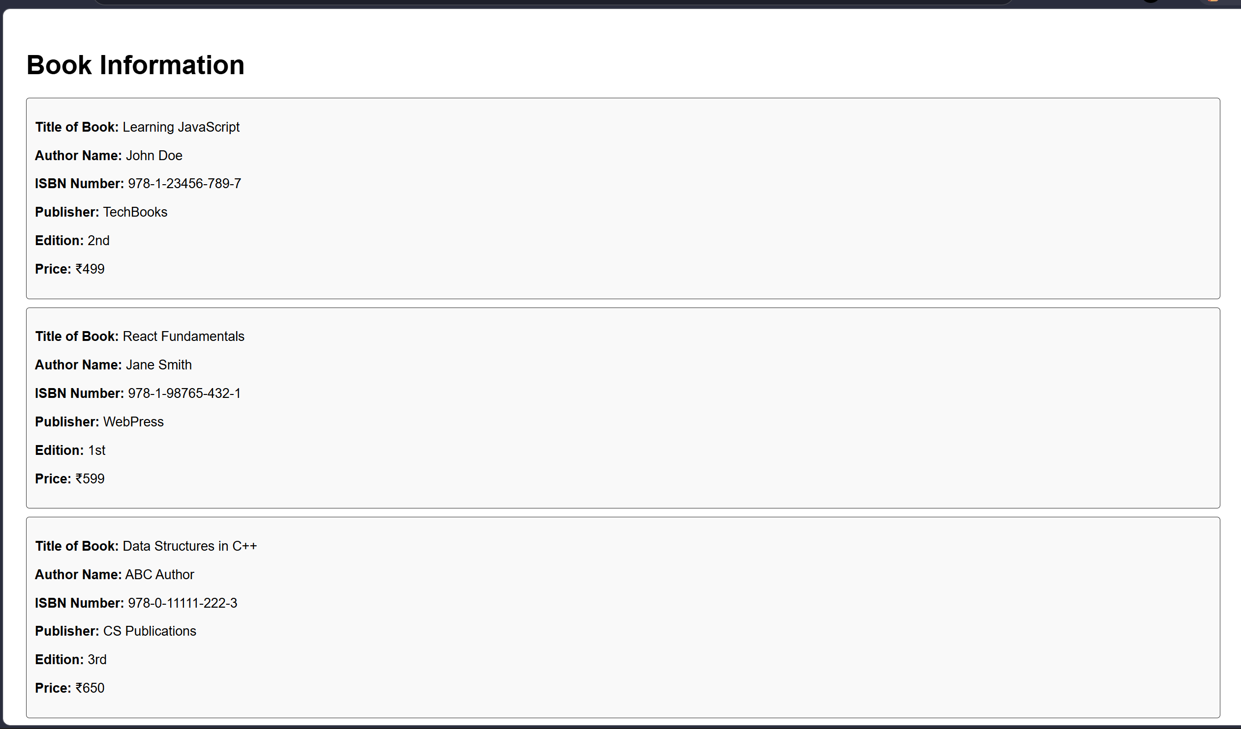

ASSIGNMENT-4
Write a java script program of form validation ?
i)Aim
To develop a JavaScript program that performs client-side validation on an HTML form by checking required fields and basic email format before allowing the form to be submitted.
ii) Description
- In this assignment, a simple HTML form is created with fields such as Name, Email and Password, and a Submit button.
- JavaScript is used to validate that all fields are not empty, the email value has a valid format and the password satisfies a minimum length before submission.
- If any validation fails, an alert message is displayed and the form submission is stopped using return false, so the user can correct the errors on the client side itself.
iii) Program
File:form_validation.html
<!DOCTYPE html> <html>
<head> <title>JavaScript Form Validation</title>
<script> function validateForm() {var name = document.getElementById("name").value.trim(); var email = document.getElementById("email").value.trim(); var password = document.getElementById("password").value.trim();
// Basic email regex pattern var emailPattern = /^[^\s@]+@[^\s@]+\.[^\s@]+$/;
if (name === "") { alert("Please enter your name."); return false; }
if (email === "") { alert("Please enter your email."); return false; }
if (!emailPattern.test(email)) { alert("Please enter a valid email address."); return false; }
if (password === "") { alert("Please enter your password."); return false; }
if (password.length < 6) { alert("Password must be at least 6 characters long."); return false; } alert("Form submitted successfully!"); return true; } </script> </head>
<body>
<h1>Registration Form</h1> <form onsubmit="return validateForm()">
<label>Name:</label> <input type="text" id="name"><br><br>
<label>Email:</label> <input type="text" id="email"><br><br>
<label>Password:</label> <input type="password" id="password"><br><br>
<input type="submit" value="Submit"> <input type="reset" value="Reset"> </form>
</body> </html>
iv) Input and Output
- Input:
The user opens form_validation.html in a browser and enters values into the Name, Email and Password fields, then clicks the Submit button.
- Output:
If any field is empty, the email format is invalid or the password is too short, JavaScript shows an alert message and prevents the form from submitting; if all validations pass, an alert “Form submitted successfully!” is displayed and the form submission continues.
v) Result
The JavaScript form validation program successfully checked user inputs for required fields, email format and password length on the client side and blocked submission when invalid data was entered, thus meeting the assignment requirement for form validation.
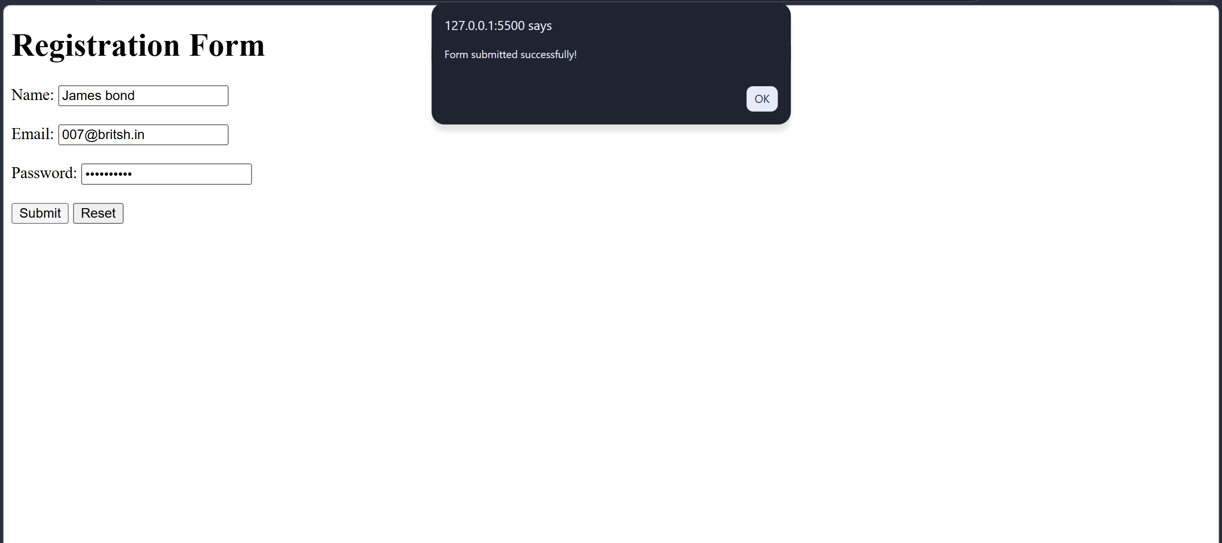

ASSIGNMENT-5
write a Java script program to check given number is palindrome or not write a ReactJS program to Calculate Sum of N Numbers
i) Aim
To develop a JavaScript program that checks whether a given number is a palindrome or not, and a ReactJS application that calculates and displays the sum of the first N natural numbers based on user input.
ii) Description
- In the first part, JavaScript is used with an HTML form to take a number from the user, reverse the digits using a loop and compare the reversed value with the original number to decide whether it is a palindrome.
- In the second part, a ReactJS functional component is created where the user enters a value N, and the component computes the sum of the first N natural numbers using the formula $sum=N×(N+1)/2$ or by converting the input to a number and calculating the sum in JavaScript, then displays the result on the page.
iii) Program
Part–A: JavaScript program to check palindrome number
File:Palindrome.html
<!DOCTYPE html> <html>
<head> <title>Palindrome Number Checker</title>
<script> function checkPalindrome() {
var num = document.getElementById("number").value;
if (num === "") { alert("Please enter a number."); return; }
var original = parseInt(num); var temp = original;
var reverse = 0; var remainder;
while (temp > 0) { remainder = temp % 10; reverse = reverse * 10 + remainder; temp = parseInt(temp / 10); }
if (reverse === original) { document.getElementById("result").innerHTML = original + " is a palindrome number."; }
else { document.getElementById("result").innerHTML = original + " is not a palindrome number."; } } </script> </head>
<body> <h1>Palindrome Number Checker</h1>
<label>Enter a number:</label> <input type="number" id="number">
<button onclick="checkPalindrome()">Check</button> <p id="result"></p> </body> </html>
Part–B: ReactJS program to calculate Sum of N numbers
Assume a Vite React project with main.jsx and App.jsx in the src folder.
File:main.jsx
import React from "react";
import ReactDOM from "react-dom/client";
import App from "./App.jsx"; ReactDOM.createRoot(document.getElementById("root")).render( <React.StrictMode> <App /> </React.StrictMode> );

File:App.jsx
import React, { useState } from "react";
function App() { const [n, setN] = useState("");
const [sum, setSum] = useState(0); f
unction handleChange(event) {
const value = event.target.value; setN(value);
if (value === "") { setSum(0); }
else { const num = parseInt(value);
if (!isNaN(num) && num > 0) {
const result = (num * (num + 1)) / 2; setSum(result); }
else { setSum(0); } } }
return ( <div style={{ fontFamily: "Arial, sans-serif", padding: "20px" }}>
<h1>Sum of N Numbers</h1>
<label>Enter N:</label>
<input type="number" value={n} onChange={handleChange} style={{ marginLeft: "10px" }} />
<p>Sum of first {n === "" ? 0 : n} natural numbers is: {sum}</p> </div> ); }
export default App;

iv) Input and Output
- Input:
  - For the JavaScript palindrome program, the user opens palindrome.html, enters a number into the input field and clicks the “Check” button.
  - For the ReactJS program, the user runs the Vite React app and types a value N in the input box on the page.
- Output:
  - The palindrome program displays a message showing whether the given number is a palindrome or not, such as “121 is a palindrome number” or “123 is not a palindrome number”.
  - The ReactJS program displays the calculated sum of the first N natural numbers, updating the result on the page whenever the input value changes.
v) Result
Both programs were successfully executed. The JavaScript program correctly checked whether a given number is a palindrome by reversing its digits and comparing with the original value. The ReactJS program accepted an integer N from the user and calculated the sum of the first N natural numbers, displaying the result dynamically in the browser, thus fulfilling the objectives of the assignment
Part-A
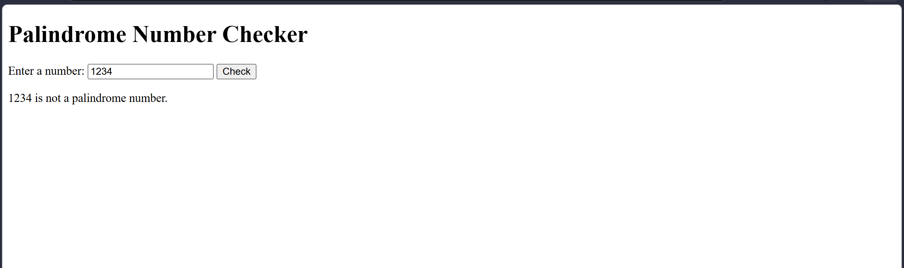
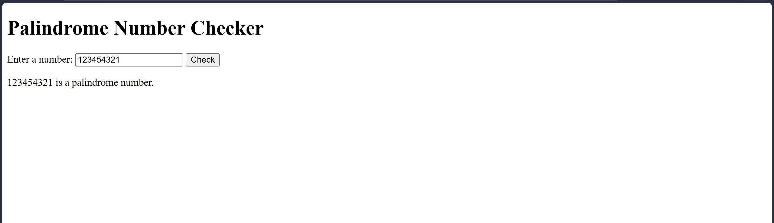

Part-B
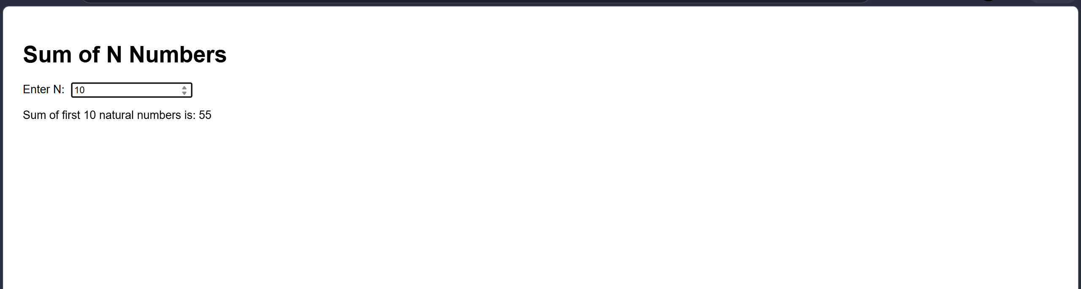

ASSIGNMENT-6
Write a javascript program to verfiy email ID and password .Develop static pages (usingOnly HTML) of an online Book store.
The pages should consist Registration and user Login
i) Aim
To develop a JavaScript program that verifies the email ID and password entered by the user using basic validation rules, and to design static HTML pages for Registration and User Login of an online book store.
ii) Description
- In the first part, JavaScript is used to validate that the email follows a basic email pattern and the password satisfies minimum length before allowing login.
- The login form contains fields for email and password; on submission, JavaScript checks the input and shows an appropriate message if the email format is invalid or the password is too short.
- In the second part, static HTML pages are created for Registration and Login of an online book store, where the Registration page collects user details and the Login page allows existing users to enter their email and password. These pages are connected with simple navigation links
iii) Program
Part–A: JavaScript program to verify email ID and password
File:login_validation.html
<!DOCTYPE html> <html>
<head> <title>Email and Password Verification</title>
<script> function validateLogin() { var email = document.getElementById("email").value.trim();
var password = document.getElementById("password").value.trim();
// Basic email pattern var emailPattern = /^[^\s@]+@[^\s@]+\.[^\s@]+$/;
if (email === "") { alert("Please enter your email."); return false; }
if (!emailPattern.test(email)) { alert("Please enter a valid email address."); return false; }
if (password === "") { alert("Please enter your password."); return false; }
if (password.length < 6) { alert("Password must be at least 6 characters long."); return false; }
alert("Login successful! Email and password are valid."); return true; } </script> </head>
<body> <h1>Online Book Store - User Login</h1>
<form onsubmit="return validateLogin()">
<label>Email ID:</label> <input type="text" id="email"><br><br> <label>Password:</label> <input type="password" id="password"><br><br>
<input type="submit" value="Login"> <input type="reset" value="Reset">
</form>
</body> </html>
Part–B: Static HTML pages for Registration and User Login
File:book_login.html
<!DOCTYPE html> <html>
<head> <title>Online Book Store - Login</title> </head>
<body> <h1>Online Book Store - User Login</h1>
<nav> <a href="book_login.html">Login</a> | <a href="book_register.html">Register</a> </nav> <br>
<form> <label>Email ID:</label> <input type="email" name="email"><br><br> <label>Password:</label> <input type="password" name="password"><br><br>
<input type="submit" value="Login"> <input type="reset" value="Reset"> </form>
</body> </html>
File:book_register.html
<!DOCTYPE html> <html>
<head> <title>Online Book Store - Registration</title> </head>
<body> <h1>Online Book Store - User Registration</h1>
<nav> <a href="book_login.html">Login</a> | <a href="book_register.html">Register</a> </nav> <br>
<form> <label>Full Name:</label> <input type="text" name="fullname"><br><br> <label>Email ID:</label> <input type="email" name="email"><br><br>
<label>Create Password:</label>
<input type="password" name="password"><br><br>
<label>Mobile Number:</label> <input type="text" name="mobile"><br><br> <label>Address:</label> <textarea name="address" rows="3" cols="30"></textarea><br><br> <input type="submit" value="Register">
<input type="reset" value="Clear"> </form>
</body> </html>

iv) Input and Output
Input:
In login_validation.html, the user enters an email ID and password and clicks the Login button.
In book_login.html and book_register.html, the user fills in the login and registration form fields respectively.
Output:
The JavaScript login page displays alert messages if the email is empty, not in valid format, or if the password is missing or too short; otherwise it shows a success message for valid email and password.
The static Registration and Login pages display simple forms for the online book store with working navigation links between them.
v) Result
The JavaScript program successfully verified the email ID and password entered by the user using client-side validation rules, preventing invalid input from being accepted. The static HTML pages for Registration and User Login of the online book store were also created and linked properly, fulfilling the requirements.
Part-A

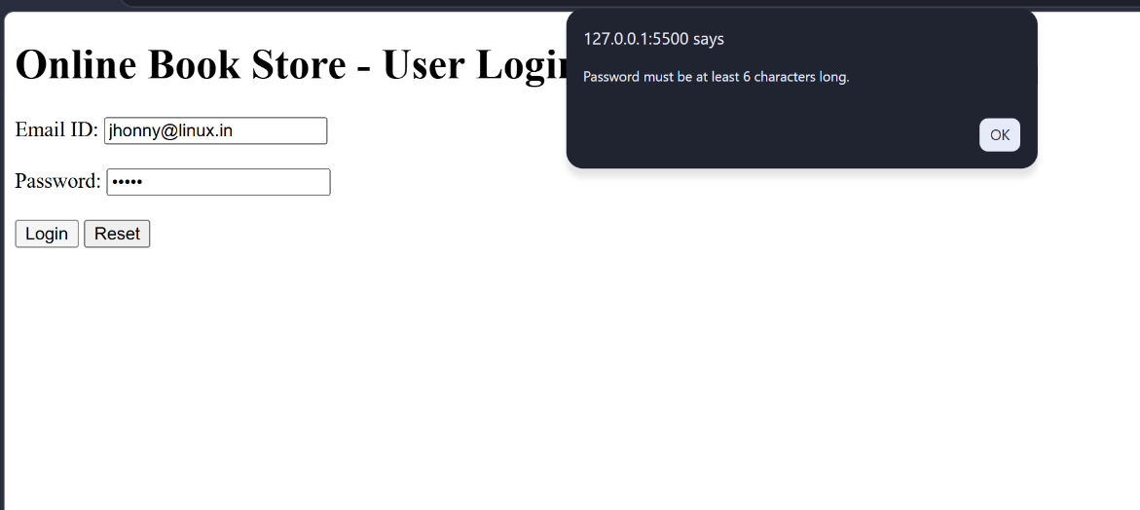

Part-B
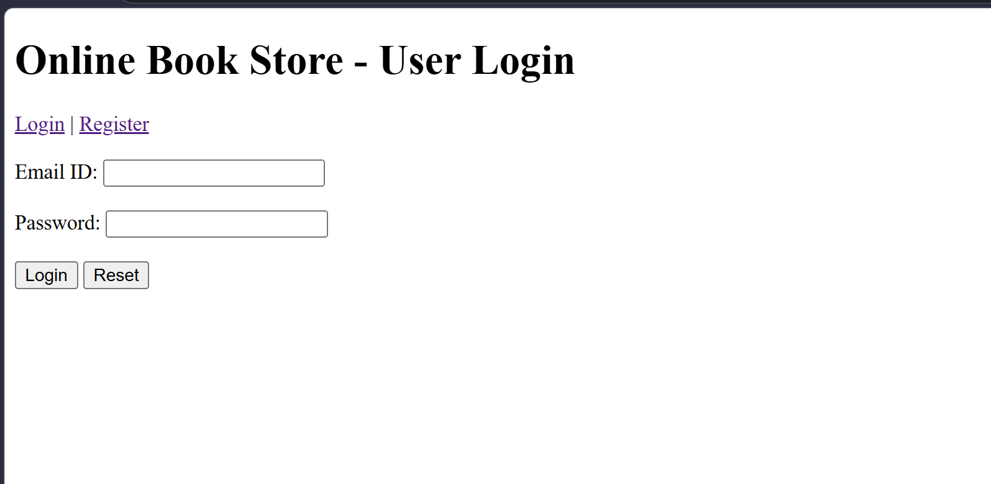
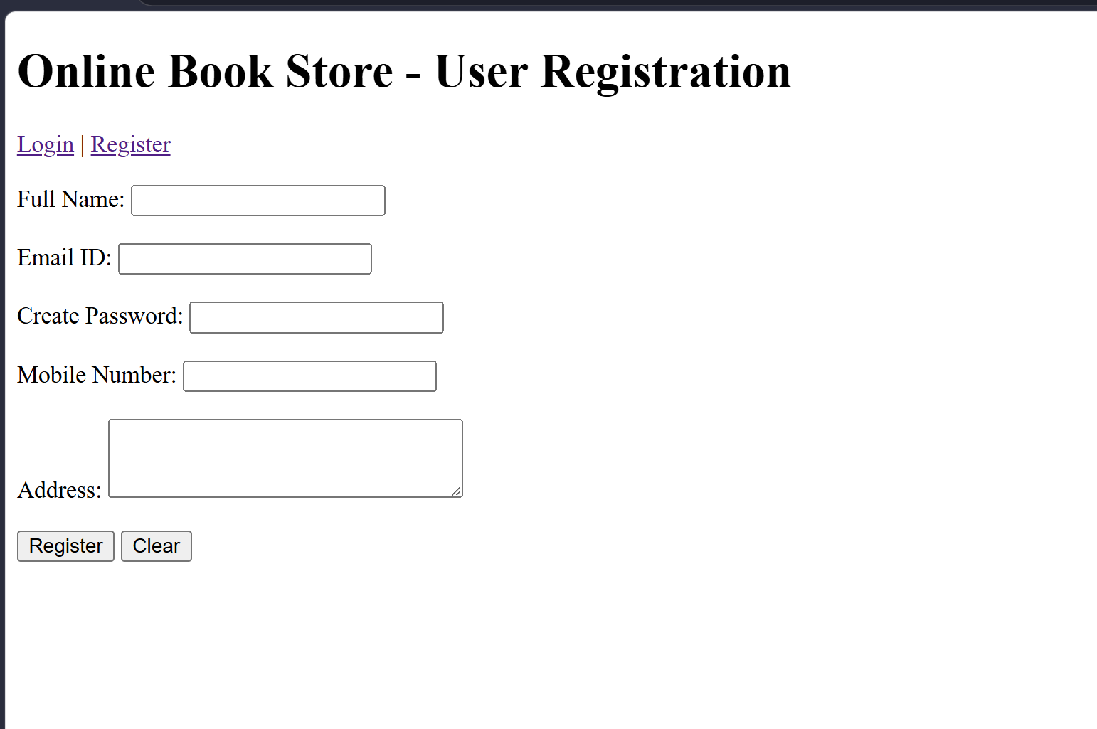

ASSIGNMENT-7
Write HTML and CSS program to display the class time table.Develop static pages (using Only HTML) of an online Book store. The pages should consist Registration and user Login
i) Aim
To design a class timetable web page using HTML and CSS, and to create static HTML pages for Registration and User Login of an online book store.
ii) Description
- In the first part, a class timetable is created using an HTML table where days of the week form the rows and time slots form the columns, and CSS is used to style borders, background colors and text alignment for better readability.
- In the second part, static HTML pages are developed for a simple online book store with separate Registration and Login pages; each page contains form controls for user details, and navigation links allow users to switch between Registration and Login.
iii) Program
Part–A: HTML and CSS program to display the class timetable
File:Timetable.html
<!DOCTYPE html> <html>
<head> <title>Class Time Table</title>
<style> body{ font-family: Arial, sans-serif; background-color: #f2f2f2; }
h1 { text-align: center; color: #333333; }
table { width: 80%; margin: 20px auto; border-collapse: collapse; background-color: #ffffff; }
th, td { border: 1px solid #555555; padding: 10px; text-align: center; }
th { background-color: #4CAF50; color: white; }
tr:nth-child(even) { background-color: #f9f9f9; }
tr:nth-child(odd) { background-color: #e6f7ff; }
.break { background-color: #ffe0b2; font-weight: bold; } </style> </head>
<body>
<h1>Class Time Table</h1>
<table>
<tr> <th>Day / Time</th> <th>9:00 - 10:00</th> <th>10:00 - 11:00</th> <th>11:00 - 12:00</th> <th>12:00 - 1:00</th> <th>1:00 - 2:00</th> <th>2:00 - 3:00</th> <th>3:00 - 4:00</th> </tr>
<tr> <td>Monday</td> <td>Maths</td> <td>Physics</td> <td>C Programming</td> <td class="break">Lunch Break</td> <td>English</td> <td>Front End Dev</td> <td>Lab</td> </tr>
<tr> <td>Tuesday</td> <td>Physics</td> <td>Data Structures</td> <td>Maths</td> <td class="break">Lunch Break</td> <td>Front End Dev</td> <td>IoT</td> <td>Sports</td> </tr>
<tr> <td>Wednesday</td> <td>Data Structures</td> <td>Maths</td> <td>English</td> <td class="break">Lunch Break</td> <td>Front End Dev</td> <td>Lab</td> <td>Library</td> </tr>
<tr> <td>Thursday</td> <td>C Programming</td> <td>Physics</td> <td>IoT</td> <td class="break">Lunch Break</td> <td>Maths</td> <td>Data Structures</td> <td>Project</td> </tr>
<tr> <td>Friday</td> <td>English</td> <td>IoT</td> <td>C Programming</td> <td class="break">Lunch Break</td> <td>Front End Dev</td> <td>Seminar</td> <td>Lab</td> </tr>
</table> </body> </html>
Part–B: Static HTML pages for Registration and User Login (online book store)
File:store_login.html
<!DOCTYPE html> <html>
<head> <title>Book Store - Login</title> </head>
<body> <h1>Online Book Store - Login</h1>
<nav> <a href="store_login.html">Login</a> |
<a href="store_register.html">Register</a> </nav>
<hr>
<form> <p> <label>Email ID:</label> <input type="email" name="email"> </p>
<p> <label>Password:</label> <input type="password" name="password"> </p>
<p> <input type="submit" value="Login"> <input type="reset" value="Reset"> </p> </form> </body> </html>

File:store_register.html
<!DOCTYPE html> <html>
<head> <title>Book Store - Registration</title> </head>
<body> <h1>Online Book Store - Registration</h1>
<nav> <a href="store_login.html">Login</a> | <a href="store_register.html">Register</a> </nav> <hr>
<form> <p> <label>Full Name:</label> <input type="text" name="fullname"> </p>
<p> <label>Email ID:</label> <input type="email" name="email"> </p>
<p> <label>Password:</label> <input type="password" name="password"> </p>
<p> <label>Confirm Password:</label> <input type="password" name="confirmpassword"> </p> <p> <label>Address:</label>
<textarea name="address" rows="3" cols="30"></textarea> </p>
<p> <label>Phone:</label> <input type="text" name="phone"> </p> <p>
<input type="submit" value="Register"> <input type="reset" value="Clear"> </p> </form> </body> </html>
iv) Input and Output
- Input:
  - For the timetable page, the user opens timetable.html in a browser; no data entry is required.
  - For the book store pages, the user opens store_login.html or store_register.html and fills in the form fields for login or registration.
- Output:
  - The browser displays a neatly formatted class timetable table showing days vs. time slots with styled rows and a highlighted lunch break.
  - The Registration and Login pages display simple forms for the online book store with navigation links between Login and Register pages.

v) Result
The HTML and CSS program successfully displayed the class timetable in a structured and styled table format, and the static HTML pages for Registration and User Login of the online book store were created and linked correctly, fulfilling the objectives
Part-A
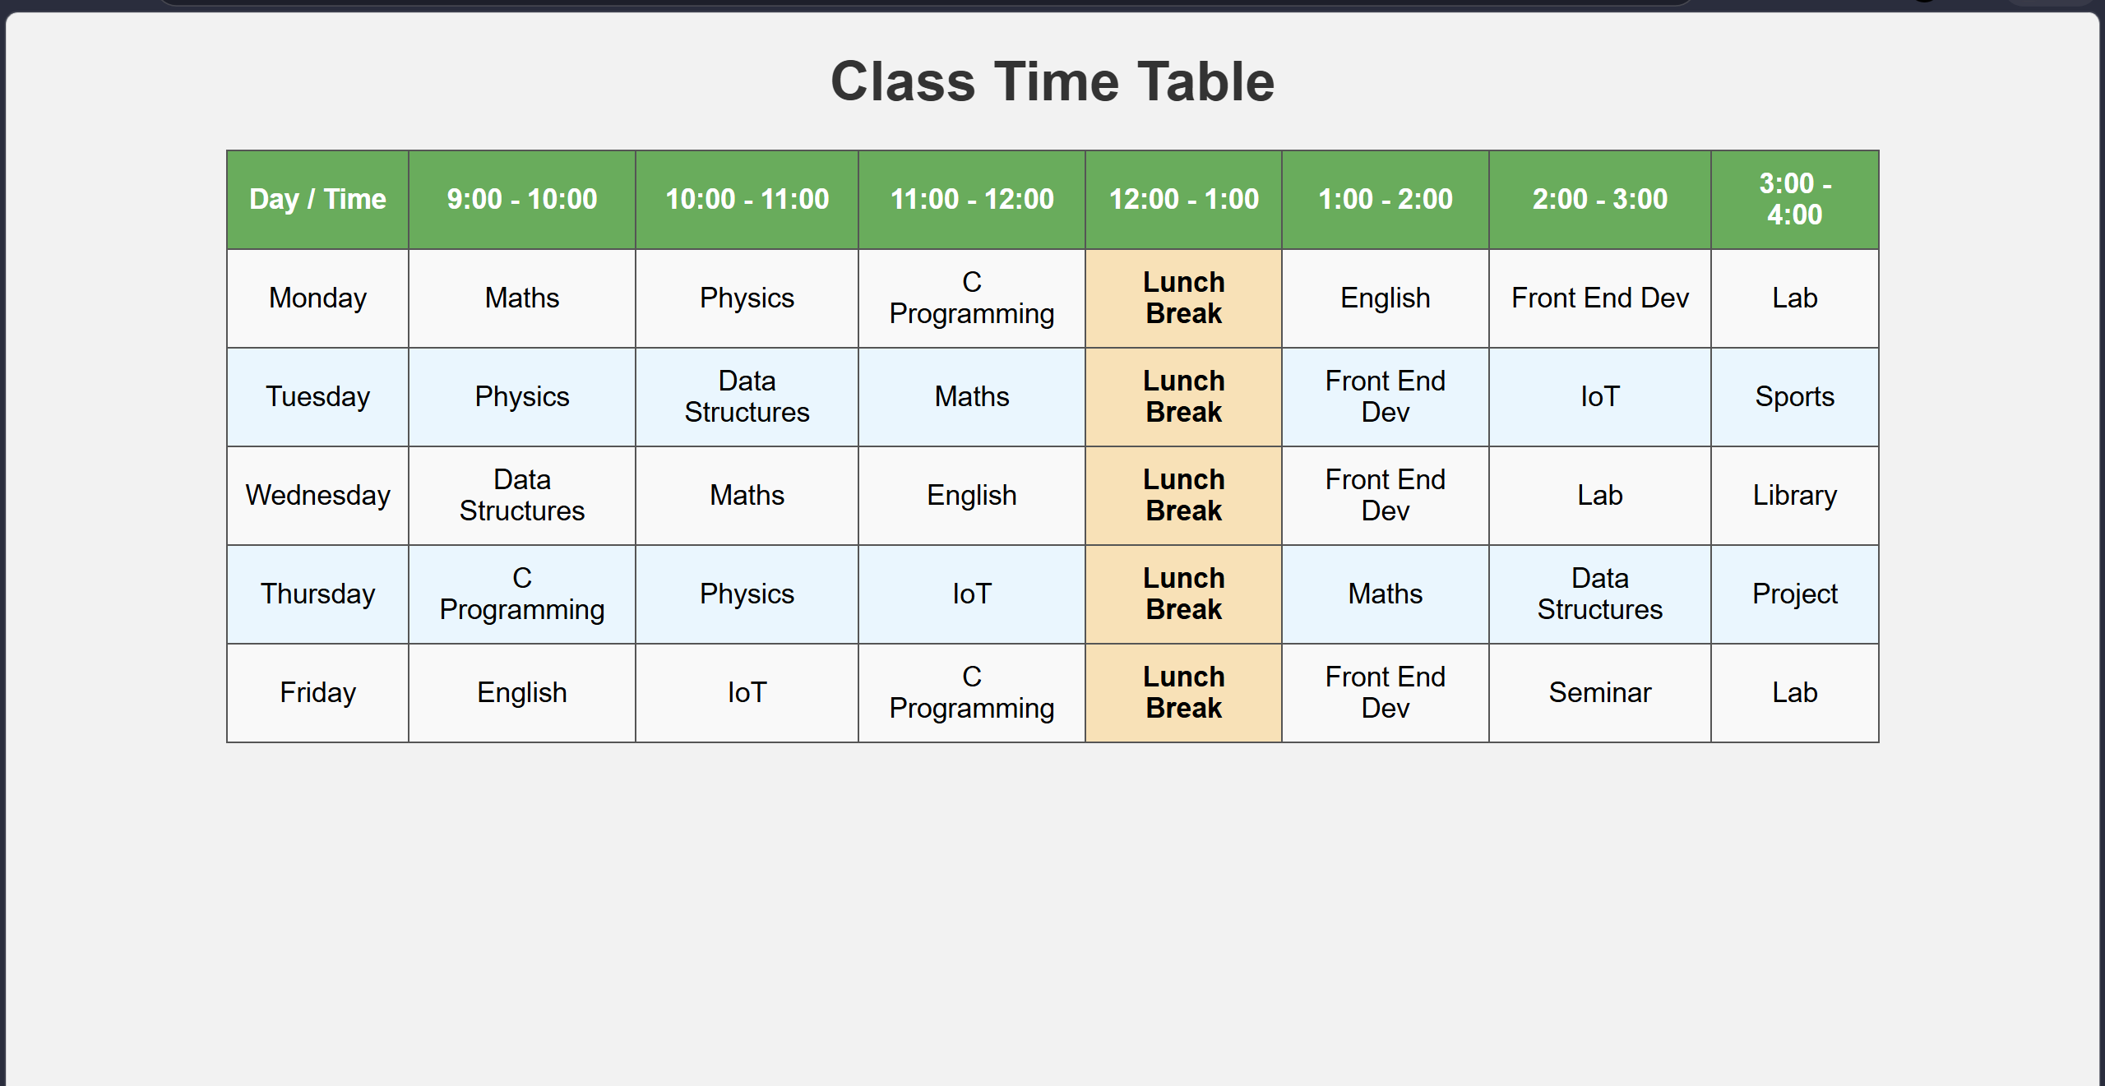
Part-B
Login page
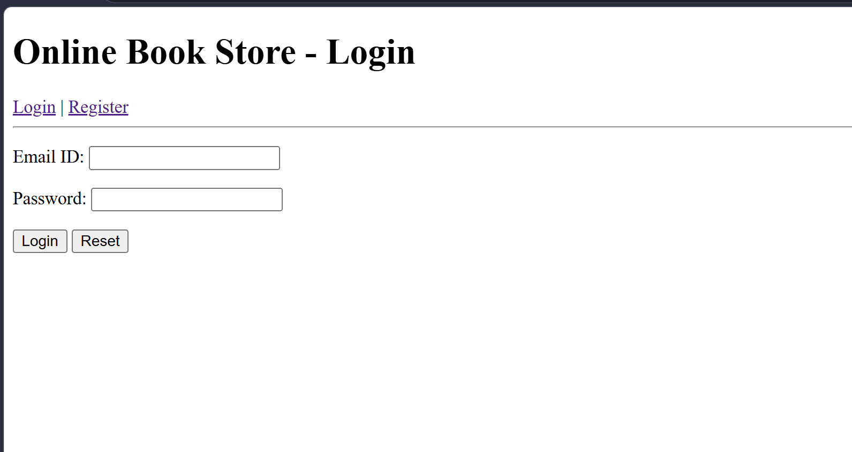

Registration page
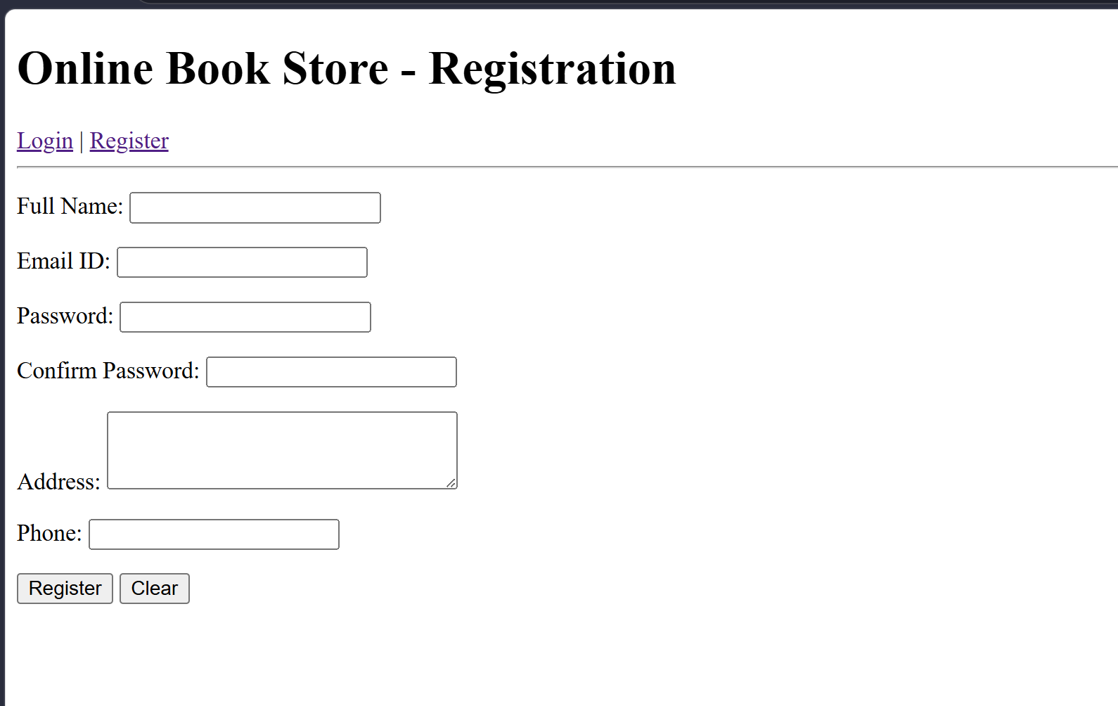

ASSIGNMENT-8
Write a ReactJS program to print the following patterns:
a)
*
* *
* * *
* * * *
* * * * *
b)
1
1 2
1 2 3
1 2 3 4
1 2 3 4 5
c)
A
A B
A B C
A B C D
A B C D E
i) Aim
To develop a ReactJS application that takes a single input N from the user and prints star, number and alphabet triangle patterns with N rows using loops and array mapping.
ii) Description
- The program provides one input box where the user enters the number of rows N, and React state is used to store this value.
- Based on N, nested loops generate arrays of strings for the star, number and alphabet triangles, and these arrays are rendered using map() so that changing N automatically updates all three patterns on the page

iii) Program
You can assume a basic Create React App structure with index.js rendering the App component.
Vite structure: src/main.jsx and src/App.jsx
File:main.jsx
import React from "react";
import ReactDOM from "react-dom/client";
import App from "./App.jsx";
ReactDOM.createRoot(document.getElementById("root")).render(
<React.StrictMode>
<App />
</React.StrictMode>);
File:App.jsx
import React, { useState } from "react";
function App() { const [rows, setRows] = useState(5);
const n = parseInt(rows) > 0 ? parseInt(rows) : 0;
const starPattern = []; const numberPattern = []; const alphabetPattern = [];
for (let i = 1; i <= n; i++) { let starRow = ""; let numberRow = ""; let alphabetRow = ""; for (let j = 1; j <= i; j++) { starRow += "* "; numberRow += j + " "; alphabetRow += String.fromCharCode(65 + j - 1) + " "; }
starPattern.push(starRow.trim());
numberPattern.push(numberRow.trim()); alphabetPattern.push(alphabetRow.trim()); }
function handleChange(event) { setRows(event.target.value); }
return ( <div style={{ fontFamily: "Arial, sans-serif", padding: "20px" }}>
<h1>React Pattern Printing</h1> <label>Enter number of rows (N):
</label> <input type="number" value={rows} onChange={handleChange} style={{ marginLeft: "10px" }} /> <h2>a) Star Pattern</h2> {starPattern.map((line, index) => ( <div key={index}>{line}</div> ))} <h2>b) Number Pattern</h2> {numberPattern.map((line, index) => ( <div key={index}>{line}</div> ))} <h2>c) Alphabet Pattern</h2> {alphabetPattern.map((line, index) => ( <div key={index}>{line}</div> ))} </div> ); }
export default App;

iv) Input and Output
- Input:
The user runs the React application and enters a positive integer N into the input field labelled “Enter number of rows (N)”.
- Output:
The browser displays three sections: a star triangle, a number triangle and an alphabet triangle, each with exactly N rows, and the patterns update automatically whenever the user changes the value of N.
v) Result
The ReactJS program successfully accepted a single user input N and generated the required star, number and alphabet patterns with N rows using loops and React list rendering, fulfilling the requirements
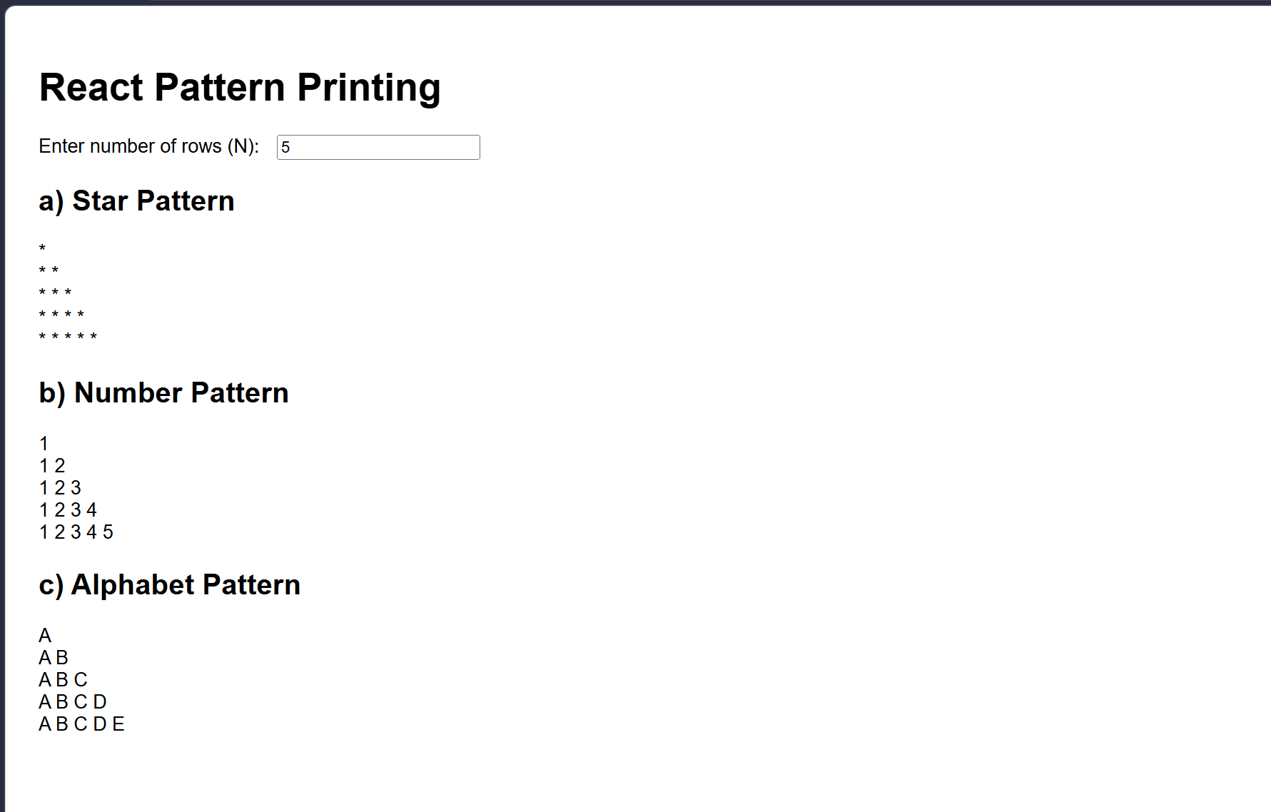

ASSIGNMENT-9
Write ReactJs program to calculate Sum of two matrices
i) Aim
To develop a ReactJS application that takes elements of two 2×2 matrices from the user and calculates their sum element-wise, displaying the resulting 2×2 matrix on the web page.
ii) Description
- In this assignment, two 2×2 matrices are represented using React state as nested arrays or individual state variables, and input boxes are provided for the user to enter each element.
- When any input changes, the application computes the sum of the corresponding elements of the two matrices and displays the resulting 2×2 matrix, demonstrating matrix addition using ReactJS.
iii) Program
You can assume a basic Create React App structure with index.js rendering the App component.
Vite structure: src/main.jsx and src/App.jsx
File:main.jsx
import React from "react";
import ReactDOM from "react-dom/client";
import App from "./App.jsx";
ReactDOM.createRoot(document.getElementById("root")).render( <React.StrictMode> <App /> </React.StrictMode> );
File:App.jsx
import React, { useState } from "react";
function App() {
const [size, setSize] = useState(2);
const n = parseInt(size) > 0 ? parseInt(size) : 0;
const [matrixA, setMatrixA] = useState([[0, 0], [0, 0]]);
const [matrixB, setMatrixB] = useState([[0, 0], [0, 0]]);
function handleSizeChange(event) {
const value = event.target.value; setSize(value);
const newN = parseInt(value);
if (!isNaN(newN) && newN > 0) {
const emptyA = Array.from({ length: newN }, () => Array.from({ length: newN }, () => 0) ); const emptyB = Array.from({ length: newN }, () => Array.from({ length: newN }, () => 0) ); setMatrixA(emptyA); setMatrixB(emptyB); } else { setMatrixA([]); setMatrixB([]); } } function handleChangeA(i, j, value) {
const newMatrix = matrixA.map((row) => row.slice()); newMatrix[i][j] = value; setMatrixA(newMatrix); }
function handleChangeB(i, j, value) {
const newMatrix = matrixB.map((row) => row.slice()); newMatrix[i][j] = value; setMatrixB(newMatrix); }
const sumMatrix = n > 0 ? Array.from({ length: n }, (_, i) => Array.from({ length: n }, (_, j) => { const aVal = Number(matrixA[i]?.[j] || 0);
const bVal = Number(matrixB[i]?.[j] || 0);
return aVal + bVal; }) ) : [];
return ( <div style={{ fontFamily: "Arial, sans-serif", padding: "20px" }}>
<h1>Sum of Two Matrices</h1>
<label>Enter matrix size (n for n × n): </label>
<input type="number" value={size} onChange={handleSizeChange} style={{ marginLeft: "10px" }} /> {n > 0 && ( <> <h2>Matrix A</h2> {matrixA.map((row, i) => ( <div key={"A-row-" + i}> {row.map((val, j) => ( <input key={"A-" + i + "-" + j} type="number" value={val} onChange={(e) => handleChangeA(i, j, e.target.value)} style={{ width: "60px", margin: "2px" }} /> ))} </div> ))} <h2>Matrix B</h2> {matrixB.map((row, i) => ( <div key={"B-row-" + i}> {row.map((val, j) => ( <input key={"B-" + i + "-" + j} type="number" value={val} onChange={(e) => handleChangeB(i, j, e.target.value)} style={{ width: "60px", margin: "2px" }} /> ))} </div> ))} <h2>Result: A + B</h2> {sumMatrix.map((row, i) => ( <div key={"C-row-" + i}> {row.map((val, j) => ( <input key={"C-" + i + "-" + j} type="number" value={val} readOnly style={{ width: "60px", margin: "2px" }} /> ))} </div> ))} </> )} </div> ); }
export default App;

iv) Input and Output
- Input:
The user runs the React application, enters an integer n as the matrix size, and then types numerical values into the n × n input grid for Matrix A and the n × n input grid for Matrix B.
- Output:
The application displays the resulting n × n sum matrix A + B, where each element is the sum of the corresponding elements of matrices A and B, and the result updates automatically whenever the user changes the matrix size or any matrix element.
v) Result
The ReactJS program successfully accepted the size and elements of two n × n matrices from the user and calculated their element-wise sum, displaying the resulting n × n matrix on the web page, thus fulfilling the objective
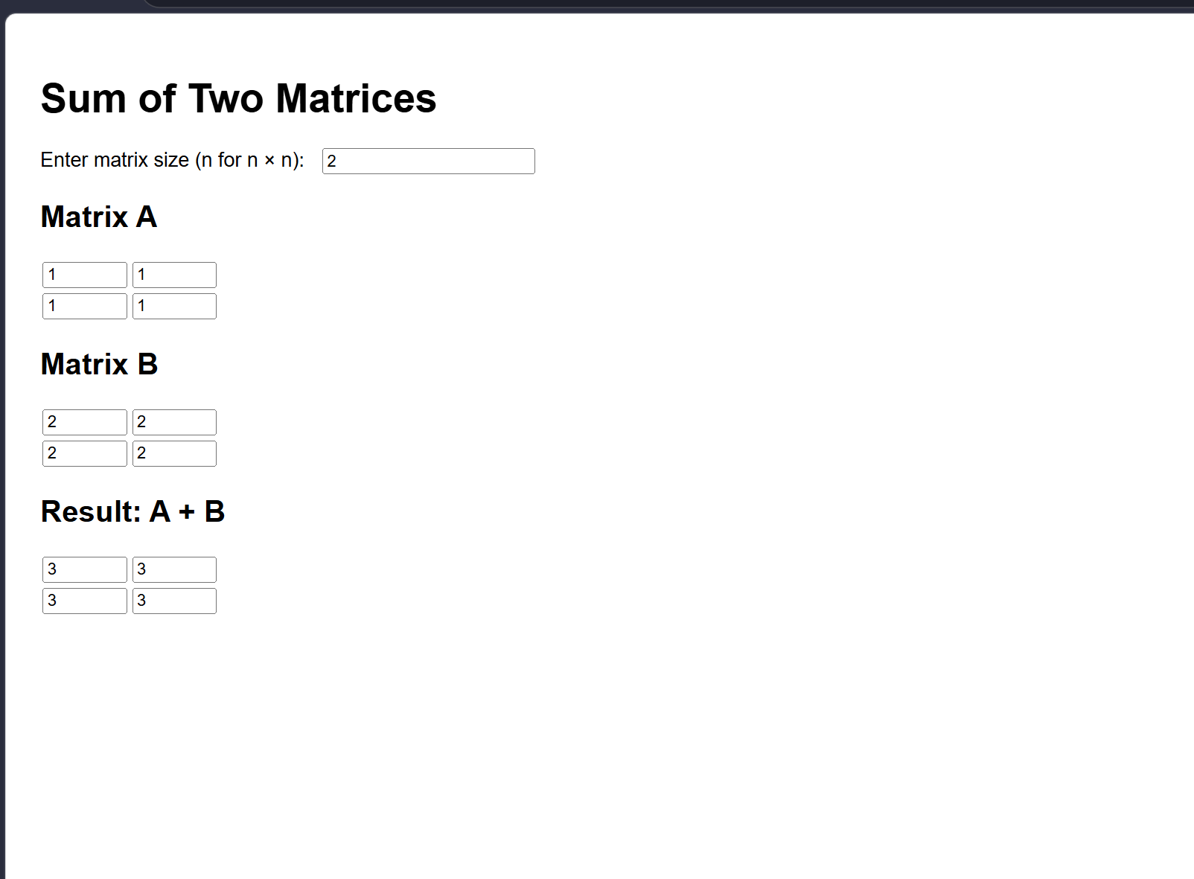

ASSIGNMENT-10
Write ReactJs Program to calculate reverse of a Number and String
i) Aim
To develop a ReactJS application that takes a number and a string as input from the user and displays their reversed forms separately.
ii) Description
- In this assignment, React state is used to store the user’s inputs for a number and a string, and simple JavaScript logic is applied to reverse each value.
- The number is reversed using string operations (convert number to string, split, reverse and join), while the string is reversed using the common split(""), reverse() and join("") pattern, and the results are shown live on the page.
iii) Program
You can assume a basic Create React App structure with index.js rendering the App component.
Vite structure: src/main.jsx and src/App.jsx
File:main.jsx
import React from "react";
import ReactDOM from "react-dom/client";
import App from "./App.jsx"; ReactDOM.createRoot(document.getElementById("root")).render( <React.StrictMode> <App /> </React.StrictMode> );
File:App.jsx
import React, { useState } from "react";
function App() { const [num, setNum] = useState("");
const [text, setText] = useState("");
function reverseNumber(value) { if (value === "") return "";
const reversed = value.toString().split("").reverse().join(""); return reversed; }
function reverseString(value) { return value.split("").reverse().join(""); }
const reversedNum = reverseNumber(num); const reversedText = reverseString(text);
return ( <div style={{ fontFamily: "Arial, sans-serif", padding: "20px" }}>
<h1>Reverse Number and String</h1> <h2>Reverse a Number</h2>
<label>Enter a number: </label>
<input type="number" value={num} onChange={(e) => setNum(e.target.value)} style={{ marginLeft: "10px" }} />
<p>Reversed Number: {reversedNum}</p>
<h2>Reverse a String</h2>
<label>Enter a string: </label>
<input type="text" value={text} onChange={(e) => setText(e.target.value)} style={{ marginLeft: "10px" }} /> <p>Reversed String: {reversedText}</p> </div> ); }
export default App;
iv) Input and Output
- Input:
The user runs the React application and enters a numeric value into the “Enter a number” field and any text into the “Enter a string” field.
- Output:
The application displays the reversed number and reversed string below their respective inputs; whenever the user changes the input values, the reversed results update immediately on the page.
v) Result
The ReactJS program successfully accepted a number and a string from the user and displayed their reversed forms using simple JavaScript reversing techniques combined with React state management, fulfilling the requirements
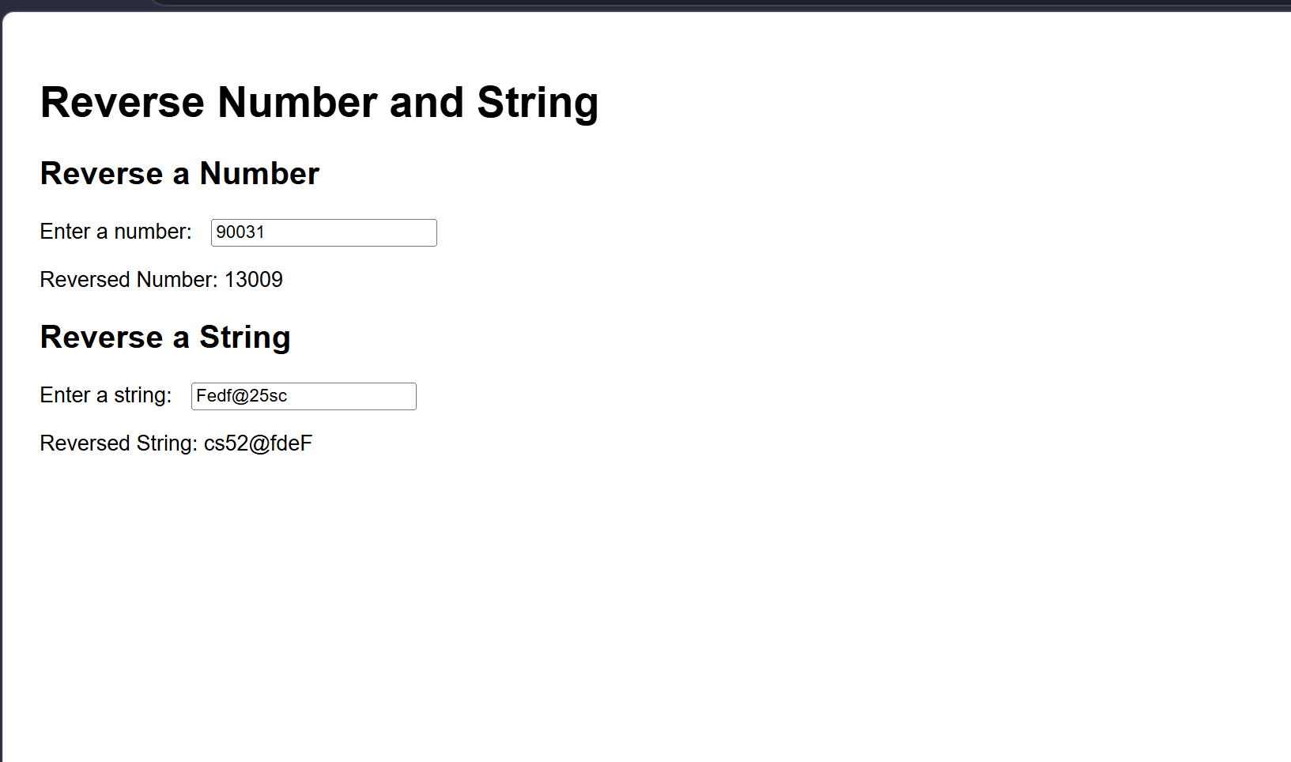
GIT HUB REPOSITORY
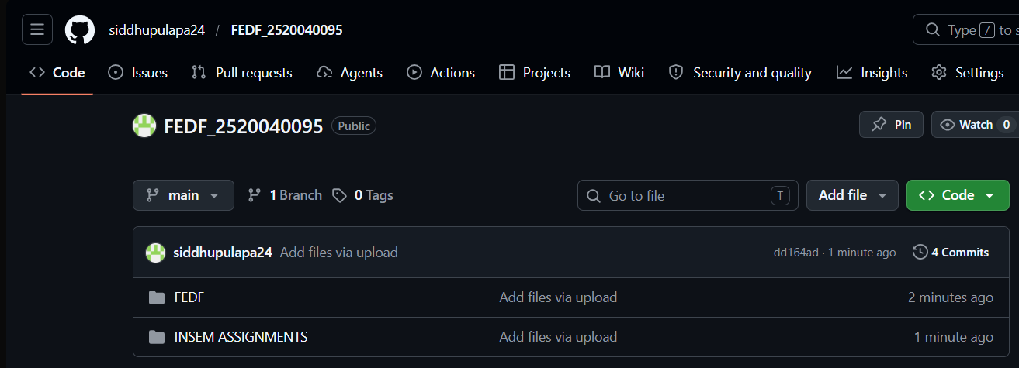

Repository Link : https://github.com/siddhupulapa24/FEDF_2520040095
Files Link:
https://github.com/siddhupulapa24/FEDF_2520040095/tree/main/INSEM%20ASSIGNMENTS
